**Z-Test**

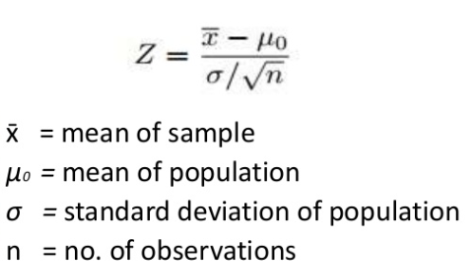

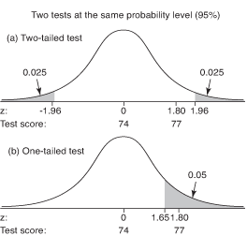

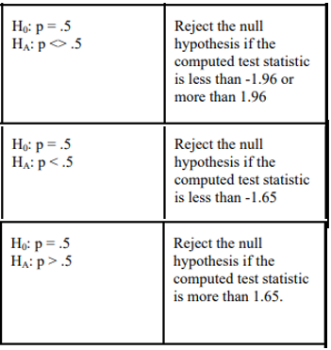

**One Tail Examples**

**1-1.** Suppose it is up to you to determine if a certain state receives significantly more public school funding (per student) than the USA average. You know that the USA mean public school yearly funding is $6300 per student per year, with a standard deviation of $400.  
Next, suppose you collect a sample (n = 100) and determine that the sample mean for New Jersey (per student per year) is $8801.  
Use the z-test and the correct Ho and Ha to run a hypothesis test to determine if New Jersey receives significantly more funding for public school education (per student per year).

**Ho : mu >= 6300**

**Ha: mu < 6300**

62.5 Point

Mu = 6300

N = 100

X = 8801

0.95

Sig = 400

0.05

Z – TEST = 62.5

--1.645 Point

**REJECT** Ha

**1-2.** An alternator manufacturer must produce its alternators so that they are 95% confident that it runs at less than 71.1o C under stress test in order to meet the production requirements for sale to the US government. The stress test is performed on random samples drawn from the production line on a daily basis. Today’s sample of 7 alternators has a mean of 71.3o C and a standard deviation of 0.214o . Is there a production quality issue?

**Ho : mu < 71.1; Ha: mu >= 71.1**

2.47 Point

Mu = 71.1

N = 7

X = 71.3

0.95

Sig = 0.214

0.05

Z – TEST = 2.47

1.645 Point

**REJECT** Ho

**Two Tail Examples**

**2-1.** [Blood glucose levels](https://www.nlm.nih.gov/medlineplus/ency/article/003482.htm) for obese patients have a mean of 100 with a standard deviation of 15. A researcher thinks that a diet high in raw cornstarch will have a positive or negative effect on blood glucose levels. A sample of 30 patients who have tried the raw cornstarch diet have a mean glucose level of 140. Test the hypothesis that the raw cornstarch had an effect.

**Ho: mu == 100**

14.60 Point

**Ha: mu != 100**

N = 30

0.025

Sig = 15

0.025

X = 140

Mu = 100

1.96 Point

--1.96 Point

Z = 14.60

**REJECT Ho**

**2-2.** A sample of 200 people has a mean age of 21 with a population standard deviation (σ) of 5. Test the hypothesis that the population mean is 18.9 at α = 0.05.

**Ho : mu == 18.9**

**Ha: mu != 18.9**

-18.54 Point

N = 200

0.025

Sig = 5

0.025

X = 21

Mu = 18.9

1.96 Point

--1.96 Point

Z = -18.54

**REJECT Ho**